[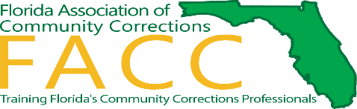](http://www.facc-net.org/)

**2025 Training Institute**

**Training Today for an informed tomorrow**

*Institute at a Glance*

|  |  |
| --- | --- |
| **Monday, July 28, 2025** | |
| 4:00pm - 6:00pm | Registration Opens |

|  |  |
| --- | --- |
| **Tuesday July 29, 2025** | |
| 7:30am | Registration Opens. Breakfast and Coffee on your own |
| 8:30am | Institute Opening Ceremony with Dignitaries from Duval County, the Florida Department of Corrections, and the Florida Department of Juvenile Justice |
| 9:30am | Networking in the Exhibit Hall |
| 9:45am | Keynote Speaker – National Speaker and Founder of Steered Straight  **Michael DeLeon** |
| 11:45am | Transition to Salon for Lunch |
| 12:00pm | LUNCH provided by FACC |
| 1:00pm | *DON’T FORGET TO VISIT OUR EXHIBIT HALL* |
|  | Registration re-opens |
| 1:15pm | Plenary Session #1 – DISC training  Understand your behavioral style and improve communication, resolve conflict and work more efficiently with colleagues |
| 3:15 pm | Networking in the Exhibit Hall! |
| 3:45pm | Plenary Session #2 – Community Forum with representatives from DOC, misdemeanor Probation and DJJ |
| 5:00pm | Registration closes for the day |
|  | |
| **Wednesday, July 30, 2025** | |
| 7:30am | Registration Opens. Breakfast and Coffee on your own |
| 8:00am | Networking in the Exhibit Hall! |
| 8:30am | Plenary Session #3 – Sovereign Citizens |
| 10:00am | BREAK – Visit our Exhibit Hall! |
| 10:30am | Plenary Session #4 – Interstate Compact  #4A Breakout for DJJ- |
| 12:15pm | LUNCH provided by FACC  FACC Business Meeting & Award Presentation |
|  | *DON’T FORGET TO VISIT OUR EXHIBIT HALL* |
| 1:45pm | Plenary Session #5 – Substance Use Trends |
| 3:00pm | Networking in the Exhibit Hall! |
| 3:30pm | Motivational Interviewing |
| 5:00pm | Registration closes |
|  | |
| **Thursday, July 31, 2025** | |
| 9:00am | Closing Speaker- TBD |
|  | **Thank you for attending!**  **See you next year!!!!** |